Software Project Management Plan (SPMP) for SmartCar Project

*Baseline version 0.1*

*Issued on : October 27, 2014*

Issued by :

Roberto

Ryant

Ryan

Steven

Issued for : Sutrisno

# Signature

The following signature indicates approval of the enclosed Software Project Management Plan.

___________________________________________

Sutrisno

# Change History

|  |  |  |  |
| --- | --- | --- | --- |
| **Version** | **Date** | **Author** | **Changes** |
| 0.1 | August 27, 2014 | Group | Initial Version |
|  |  |  |  |

# Preface

This document delivers the proposed plan to be taken by our group to meet the needs of software to complete a OOP Project. In order to do so, we as a group will make a program using java programing language in various platforms (Notepad++ & Eclipse) to make our project ideas come to fruition.

This SPMP is intended to be used for the making of smart car project. So the lecturer will know our project and how our group make the project to a reality.

***Important Notes for Soft-copy Viewing***

This copy of document are delivered in docx format, so please be aware that you must have Microsoft Office installed to your computer especially Microsoft Word if you want to see this document.

# Table of Contents

Contents

Signature i

Change History ii

Preface iii

Table of Contents iv

List of Figures v

List of Tables vi

Chapter 1 1

1.1 Project Overview 1

1.1.1 Purpose, Scope, and Objectives 1

1.1.2 Assumptions and Constraints 1

1.1.3 Project Deliverables 2

Chapter 2 3

2.1 Software Process Model 3

2.2 External Interfaces 3

2.3 Internal Structure 3

2.4 Roles and Responsibilities 3

2.5 Tools and Techniques 4

2.5.1. Development Techniques 4

2.5.2. Tools 4

Chapter 3 5

3.1 Work Diagram 5

3.2 Responsibility Assignment Matrix (RAM) 6

3.3 Activity Diagram 7

# List of Figures

**External Interface Chart** ….……………………..........................……………………………...3

**Implicit Interface Chart** ………………………………………………………………………..3

# List of Tables

**Work Diagram/Gann Chart**.....………………………………………………………….............6

**Responsibility Assignment Matri**x...............................................................................................7

**Network Diagram**……………………………………………………………………......……….8

# Chapter 1

**INTRODUCTION**

## 1.1 Project Overview

This project consists of the component of a smart car and the environment which include:

* Simulation (Main Class)
* Car
* HUD (Heads-up Display)
* Sensor
* Machine
* Obstacle
* Tire
* Road

### 1.1.1 Purpose, Scope, and Objectives

The purpose of this project is to simulate how a Smart Car works in a real life situation for example how the car response to an obstacle, how was the tire condition, how the car sensor worked, etc.

The scope in this project are how the car react to something in front of the car with the sensor that are available in the car or to know what are the condition on the car surroundings.

The objectives of the project are mentioned as follows :

* Complete the project by the due date
* Meet all the requirements that are mentioned in the project documentation.

### 1.1.2 Assumptions and Constraints

Here is the list of all assumptions that are made :

* GUI is not the top priority
* Using International System of Units
* Car will move based on accelerated linear motion rule.
* As the speed goes up, then the temperature goes up
* If the car run too long and the tire hold the car weight, then the pressure on the tire will decrease.
* Car will slow down if the tire pressure less than 10% of its initial position
* Car will turn, if the car close with a obstacle or on certain speed
* Track always straight
* Lights will on at night.
* If there are many obstacle, obstacle will be filled at the same row
* Car will stop if the tire pressure is empty
* Carl light intensity is 100 candela

Here is the list of all constraints that are made :

* Budget
  + $ 0
* Time
  + 2 months

### 1.1.3 Project Deliverables

The items that we want to deliver are:

* Software program, along with its environment and supporting libraries.
* Software documentation
  + Installation documentation
  + End-user documentation
* Installation of software program along with its environment and supporting libraries.
* Project documentation
  + Software Project Management Plan (SPMP)
  + Software Requirement Specification (SRS)
  + Software Design Description (SDD)
  + Software Test Documentation (STD)
  + Software Test Plan (STP)
  + Software Quality Assurance Plan (SQAP)
  + Software Configuration Management Plan (SCMP)

# Chapter 2

**PROJECT ORGANIZATION**

## 2.1 Software Process Model

*Use this part to state what software process model that you choose. Mention any consideration that you put in choosing it. Remember, whatever software process model you choose here should affect the whole project’s run.*

## 2.2 External Interfaces



## 2.3 Internal Structure



## 2.4 Roles and Responsibilities

Will be attached in Chapter 3.2 Responsibility Assignment Matrix (RAM)

## 2.5 Tools and Techniques

2.5.1. Development Techniques

The project uses eclipse as a program that our group uses to make this project and the techniques that our group will use are Object Oriented techniques such as inheritance, polymorphism, class, encapsulation, etc.

### 2.5.2. Tools

Operating System

* Microsoft Windows 7
* Microsoft Windows 8

Project Management

* Notepad++
* Eclipse

Documentation

* Microsoft Word 2010

# Chapter 3

**PROJECT MANAGEMENT PLAN**

## 3.1 Work Diagram

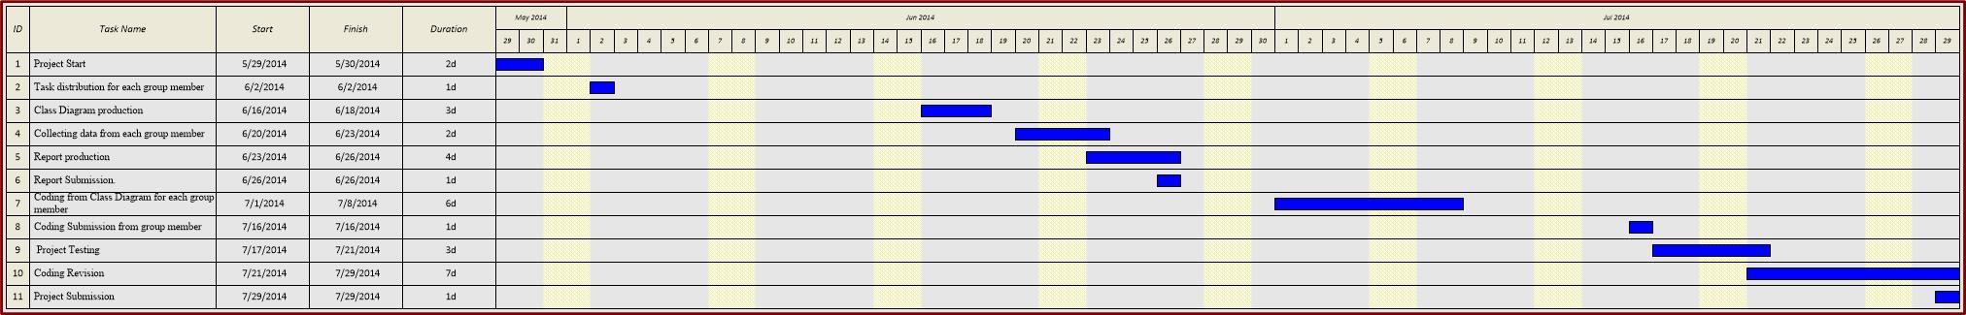

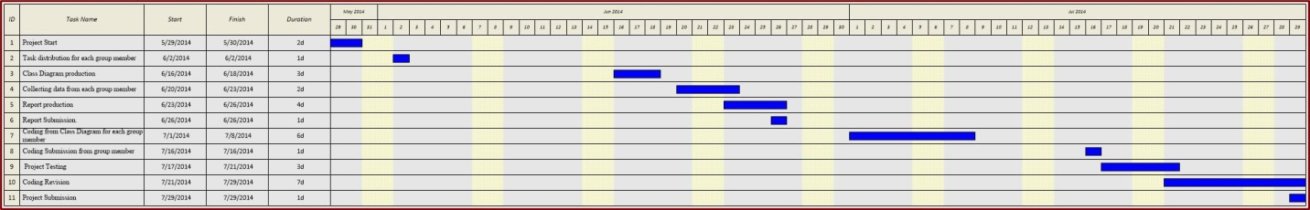

Due to unclearness of the Gantt chart we will include the raw .jpg file so it will make the picture clearer rather than the picture in this word format.

## 3.2 Responsibility Assignment Matrix (RAM)

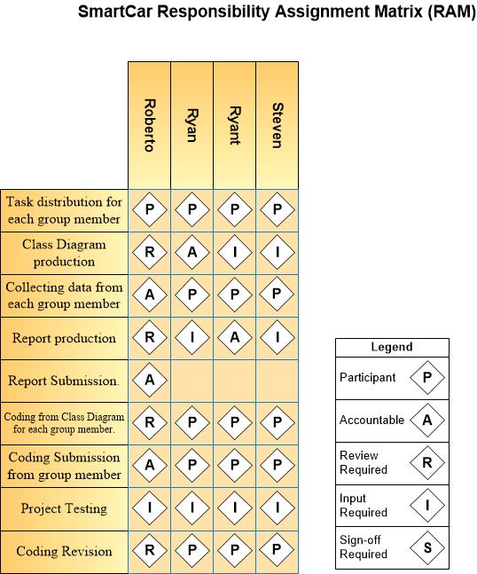

## 3.3 Activity Diagram

